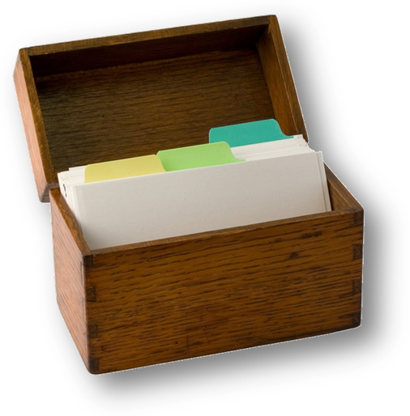
The Shark Bar
By Chef Terry Mullin



Appetizers:
Boneless Buffalo Chicken

Ingredients:

- Chicken (boneless nuggets) 4 oz.
- Texas Pete Buffalo Sauce 12 oz.
- Butter 1 stick
- Fresh Lime juice 1 lime
- Carrot and Celery Sticks for Garnish
- Ranch Dressing for Dipping

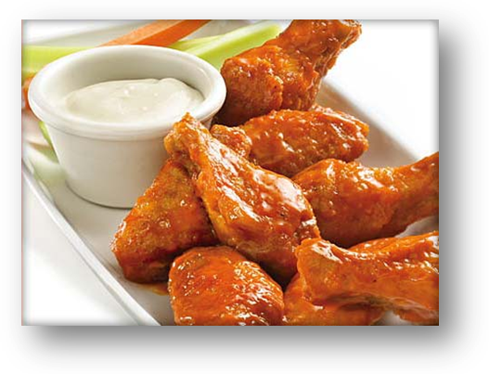
Method:

- Deep Fry nuggets until done
- In a large bowl, toss chicken and sauce to coat the chicken evenly.
- Serve with carrots and celery sticks. Use Ranch for dipping.

Bruschetta

Ingredients:
- Italian (Ciabatta) or French bread cut in 1/2 inch slices, 4 per serving
- fresh, ripe, firm tomato, washed and coarsely chopped
- fresh basil leaves, whole or shredded
- baby mozzarella, cut into small cubes
- olive oil, extra virgin, the best
- garlic, peeled, whole (optional)
- salt to taste
- Method:
- Place the tomatoes, basil, garlic (chopped fine), olive oil, diced mozzarella and salt in a bowl and mix.
- Spoon mixture on top of toasted slices. 4 slices = one serving.
- Arrange on plate

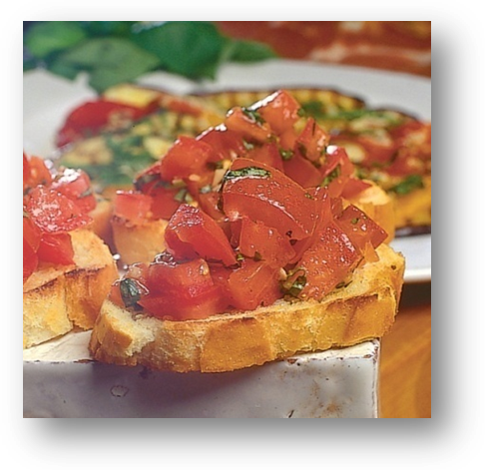

Cheesy Fries
Ingredients:
- French Fries Regular Serving
- Shredded Cheddar 3 oz.
- Sour Cream 2 oz.
- Green Onions, chopped Garnish

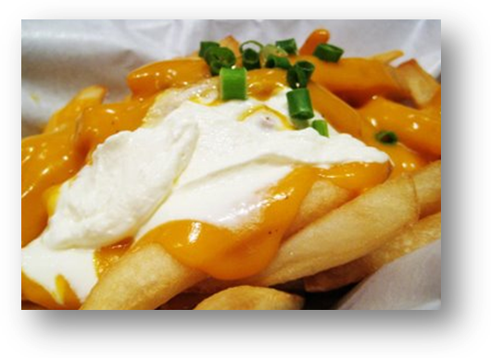

Method:

- Fry French fries until golden brown.
- Top with shredded cheese and bake in oven or under salamander until melted.
- Top with sour cream and green onions

Chicken Quesadilla
Ingredients:
- 1 large tortilla
- Green and Red Pepper slices
- Onion Slices
- Oil to sauté
- 1/4 c. chopped chicken
- 1/4 c. shredded cheddar cheese
- Shredded Lettuce
- Diced Tomatoes
- Sour Cream
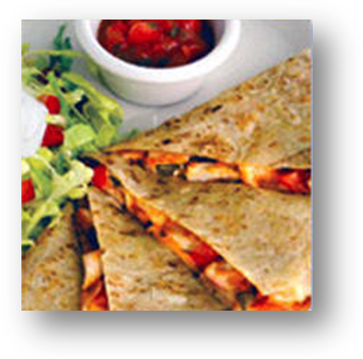
- Guacamole
- Salsa

Method:
- Butter one side of each tortilla and lay tortilla on grill, buttered side down.
- Sauté onions, peppers and chicken until hot and vegetables are tender. Spread filling across ½ the tortilla. Top with cheese
- Cook until tortilla has browned and cheese has melted. Fold tortilla in half and remove from grill.
- Cut into 4 wedges. Serve with lettuce and tomato garnish, sour cream, guacamole and salsa.

Deep Fried Onion Rings

Ingredients:
- Onions, Yellow cut into ¼ inch rings
- Fry Krisp Batter mix. Prepare according to package directions.

Method:
- Dip onions into batter mix and drop in fryer. Cook till golden brown, turning to cook both sides.

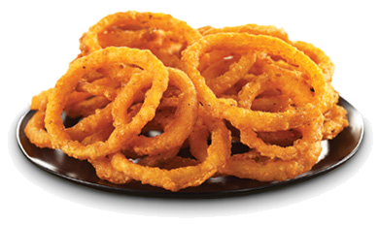

Grilled Veggies w/ Cheese

Ingredients:
- Zucchini, Sliced
- Squash, Sliced
- Red Peppers, large dice
- Onions, Large dice
- Green Peppers, large dice
- Mushrooms, Large slices
- Mozzarella Cheese
- Method:
- Grill the veggies on the char broiler
- Place veggies on plate and top with cheese.
- Melt cheese under broiler or in oven

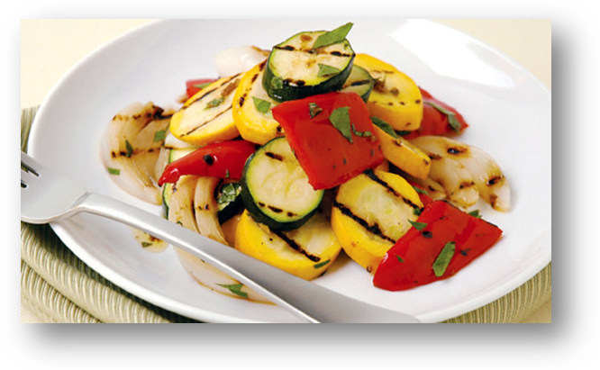

Meatballs in Curry Sauce

Ingredients:
Meatballs, frozen
Curry Sauce:
Green Curry Paste 4 oz.
Peanut Butter 1 small jar
Coconut Milk 3 cans
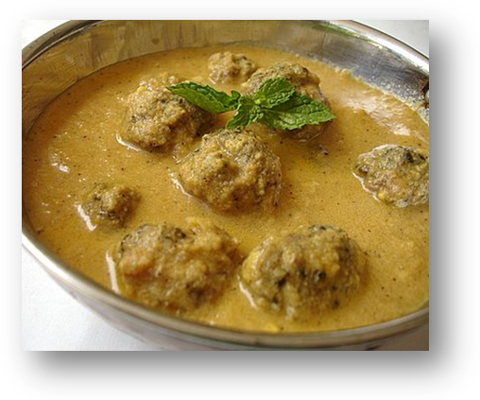
Method:
- Deep fry meatballs till hot
- Top with heated curry sauce

To make sauce:
- Mix curry paste and peanut butter in sauce pan and cook over medium heat.
- Add cans of coconut mil, one at a time.
- Serve hot over meatballs.

Mozzarella Sticks

Ingredients:
Mozzerella Sticks, Frozen 8 pieces
Marinara Sauce, heated 2 oz.
Method:
- Deep Fry mozzarella sticks until golden brown
- Serve with premade Marinara Sauce for dipping

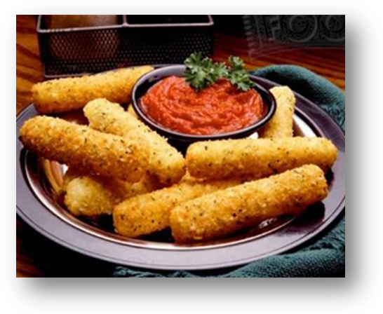

Nachos (Queso or Salsa)
Ingredients:
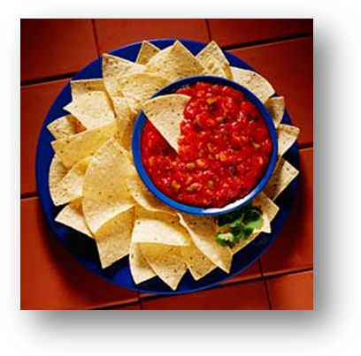
Nacho Chips Retail product
Queso (warmed) or Salsa Retail product
Place chips in basket. Serve with warm Queso or Salsa
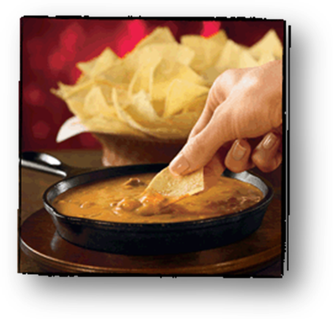

Spinach Artichoke Dip

Ingredients:
- 1 (14 ounce) can artichoke hearts, drained
- 1/3 cup grated Romano cheese
- 1/4 cup grated Parmesan cheese
- 1/2 teaspoon minced garlic
- 1 (10 ounce) package frozen chopped spinach, thawed and drained
- 1/3 cup heavy cream
- 1/2 cup sour cream
- 1 cup shredded mozzarella cheese

Method:
- Preheat oven to 350 degrees F (175 degrees C). Grease a 9x13 inch baking dish.
- Chop artichoke hearts and garlic to a small dice. Add Romano cheese and Parmesan cheese.
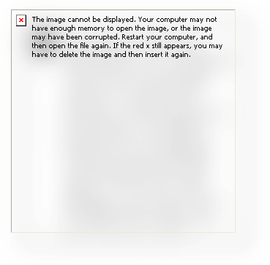
- In a medium bowl, mix together spinach, heavy cream, sour cream and mozzarella cheese. Stir in artichoke mixture. Spoon into prepared baking dish. (Alternatively, use an Alfredos sauce in place of the heavy cream and sour cream mixture.)
- Bake in the preheated oven for 20 to 25 minutes, or until cheese is melted and bubbly

Spring Rolls

Ingredients:
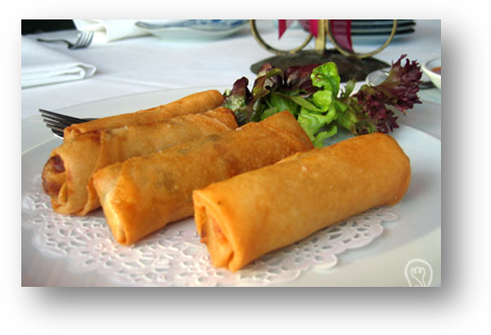
Spring rolls Retail Product
Method:
- Deep fry until center is hot.
- Cut on bias and serve with Tamari Sauce
Tamari Sauce:
- 1 part Tamari (seasoned vinegar)
- 3 parts olive oil
- Sesame Seed

Stuffed Baby Portabella

Ingredients:
- Baby Portabella Mushrooms
- Spinach Filling
- Clarified butter
- Mozzarella cheese
Filling:
- Chopped cooked spinach, well drained
- Alfredos Sauce
- Borsin Garlic Cheese

Method:
- Wash and stem mushrooms.
- Place mushrooms in casserole dish stem side up
- Add a small amount of clarified butter on the bottom of the dish
- Fill mushrooms with spinach filling mixture
- Top with mozzarella cheese
- Bake in hot oven until bubbly hot

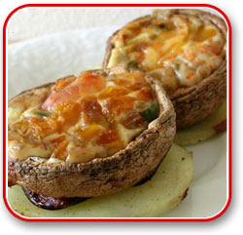

Thai Chicken Sticks (Satay)

Ingredients:
- 1 pound boneless skinless chicken breast or chicken tenderloins
- 1/3 cup soy sauce
- 2 tablespoons fresh lime juice
- 2 cloves garlic, minced
- 1 teaspoon grated gingerroot
- 3/4 teaspoon red pepper flakes
- 2 tablespoons water
- 3/4 cup canned unsweetened coconut milk
- 1 tablespoon creamy peanut butter
- 4 green onions with tops, cut into 1-inch pieces
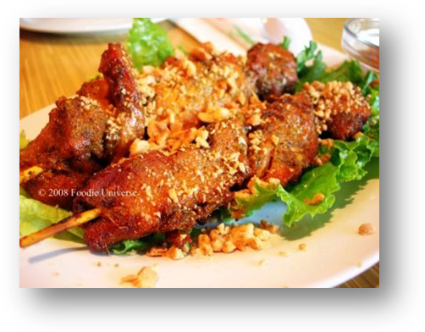
Method:
- Cut chicken crosswise into 3/8-inch-wide strips; place in shallow dish.
- Combine soy sauce, lime juice, garlic, ginger and red pepper flakes in small bowl. Reserve 3 tablespoons mixture; cover and refrigerate. Add water to remaining mixture. Pour over chicken; toss to coat well. Cover; marinate in refrigerator at least 30 minutes or up to 2 hours, stirring mixture occasionally.
- Soak 8 (10- to 12-inch) bamboo skewers 20 minutes in cold water to prevent them from burning; drain.
- Meanwhile, for peanut sauce, combine coconut milk, 3 tablespoons reserved soy sauce mixture and peanut butter in small saucepan. Bring to a boil over medium-high heat, stirring constantly. Reduce heat and simmer, uncovered, 2 to 4 minutes or until sauce thickens. Keep warm.
- Drain chicken; reserve marinade. Weave 3 to 4 chicken strips accordion-style onto each skewer, alternating with green onion pieces. Brush chicken and onions with reserved marinade.
- Place skewers on grid. Grill skewers 6 to 8 minutes or until chicken is no longer pink, turning halfway through grilling time. Serve with warm peanut sauce for dipping.

Burgers and Sandwiches:
Hamburger:
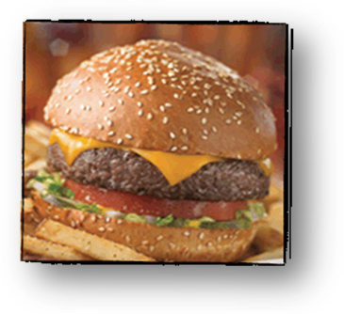
Hamburger 8 oz patty (85/15)
Soft Bun, grilled 1 bun
Lettuce Leaf, Romaine ½ leaf
Tomato Slice 2 thin slices
Onion, Yellow 1 thin slice
Pickle, Slices 3 slices
Cheeseburger:
Same as Hamburger, add one of the following:
• Swiss 2 slices 5# stack
• American 2 slices 5# stack
• Cheddar 2 slices 1# sliced/paper divider
Bacon Burger:
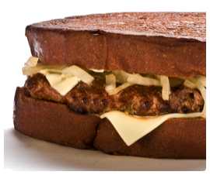
Same as Hamburger
Bacon, Cooked 2 strips
Patty Melt
Hamburger, broiled 8 oz. patty
Grilled Onions 3 oz.
Swiss Cheese 2 slices
Rye Bread, Grilled 2 slices

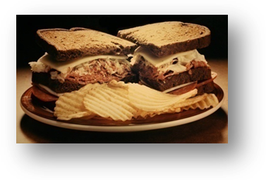
Ham & Swiss - Shark Style
Ham, Thin Sliced, Grilled 4 oz
Swiss Cheese 2 slices
Tomato 2 slices
Grilled Onion 3 oz.
Rye Bread, Grilled 2 slices

Pork Tenderloin

Ingredients:
Boneless Cutlet 6 oz.
Standard Breading Procedure:
- Seasoned Flour
- Egg wash
- Bread Crumbs
- Salt and Pepper
Method:
- Pound cutlet to ¼ inch thickness
- Dip in Seasoned flour, Egg Wash, then Bread crumbs. Be sure to pat crumbs firmly onto the product.
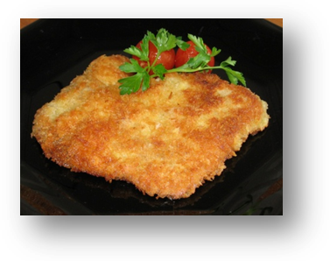
- Deep Fry until golden brown. Product will float so you may need to turn to fry both sides.

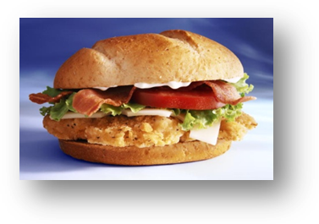
Chicken Club
Broiled Chicken Breast
Bacon, Lettuce, and Tomato
Mayo on our house bun.

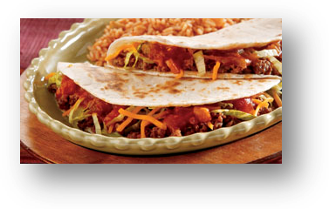
3 Amigos Tacos
3 flour tortillas Warmed on grill
Chicken or Hamburger 2 oz. per taco
Lettuce, tomato, then cheese on top
sour cream zig zag on top (w/squeeze bottle)

Taco Filling:
Chicken:
Boil chicken, Remove from bone
Chop into medium dice
Season with Taco Seasoning Mix
Add water to allow mixture to be evenly distributed
Heat to order
Hamburger:
Sauté hamburger to brown, remove any liquid
Season with Taco seasoning Mix
Add water to allow mixture to be evenly distributed
Heat to order

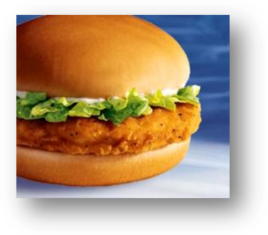
Ranch Chicken
Breaded Chicken Cutlet retail product
shredded lettuce and tomato on top
ranch dressing on top

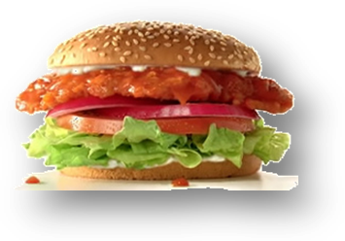
Buffalo-Style Chicken
Dip our breaded chicken cutlet in Wing Sauce
Finish like Ranch cutlet

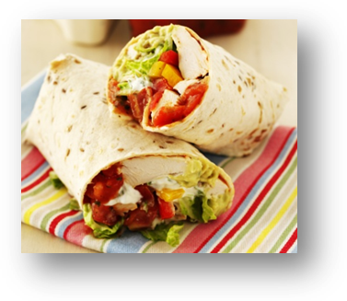
Chicken Wrap
- Tortilla 1 large
- Cream cheese 2 oz. spread on tortilla
- Chicken breast 6 oz. Broiled, then sliced
- Cheddar cheese 2 oz.
- Spinach, romaine, peppers, onions
- Guacamole sauce 2 oz.
Roll together and cut on bias

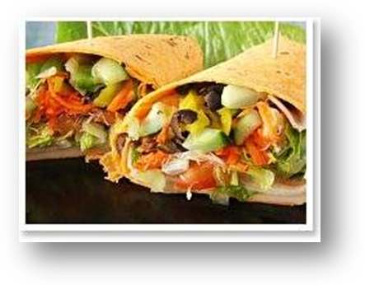
Thai Veggie Wrap
- Tortilla 1 large
- Cream cheese 2 oz. spread on tortilla
- Chicken breast 6 oz. Broiled, then sliced
- Cheddar cheese 2 oz.
- Spinach, romaine, peppers, onions
- Guacamole sauce 2 oz.
- Peanut Sauce (Satay Sauce) 2 oz.
Roll together and cut on bias

Veggie Burger
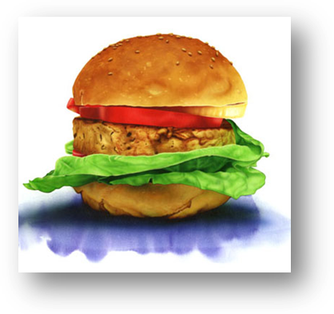
- Vegetarian burger
- Lettuce, tomato and onion
- soft bun

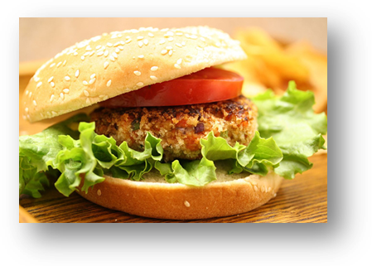
Salmon Burger
- Salmon fillet 4 oz, broiled
- Honey mustard sauce Basted on cooked fillet
- Lettuce, tomato and onion
- Soft bun.

Soups:
French Onion

Ingredients:
- Beef Base
- Chicken Base
- Yellow Onions, cut in ½ then sliced thin
- Garlic Crouton 1 large
- Swiss Cheese bowl 2 slices, cup 1 slice
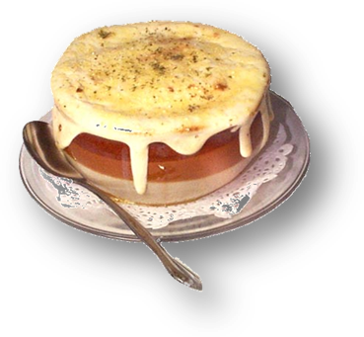
- Chopped Parsley Garnish

Method:
- Fill pot with water and add equal parts of soup base to make a broth. Add onions and simmer until tender.
- Slice French bread into ¼ inch slices. Brush with garlic butter and toast to a crouton.
- Fill cup or bowl with soup leaving room for the crouton. Add crouton and top with Swiss cheese. Bake or broil to melt cheese.

Note: be sure to fill cups with enough broth so that the crouton does not absorb all the broth. Don’t cut the crouton thick as this will mean that the amount of broth absorbed will be more than desired.

Chili (in season)

Ingredients:
- Hamburger 5 #
- Onion, diced 1 large yellow
- Garlic Salt
- Course ground black pepper
- Chili Powder 1 large
- Diced Tomatoes 2 - #2 cans
- Tomato Juice 2 – 46 oz. cans
- Tomato Sauce 2 - #2 cans
- Red Beans, rinsed 2 #2 cans
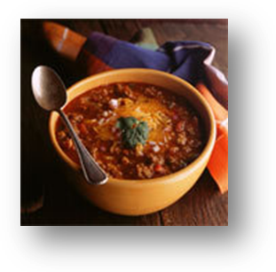
Method:
- Season hamburger with garlic salt and black pepper. Brown off hamburger then drain off liquid
- Add chili powder and mix well.
- Add diced tomatoes, juice and sauce. Simmer to expand the flavor.
- Add rinsed beans.

Salads & Dressings
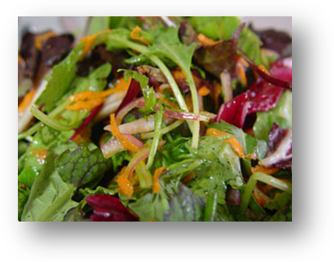
Classic Tossed
- Fresh crisp Greens
- Tomato Wedge 2
- Cucumber Slices 2
- Red Onions, sliced thin 3 rings
- Salad Dressing on the side

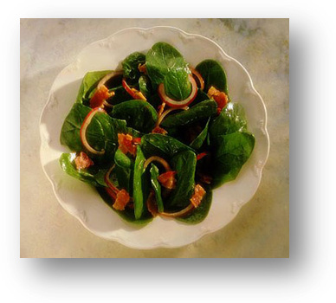
Hot Bacon Spinach
- Baby Spinach Greens fill bottom of plate
- Hard boiled egg ½
- Sliced mushrooms 3-4 slices
- Red onions 3 rings
- Croutons topped 6-8 pieces
- Hot Bacon dressing 3 oz.

Hot Bacon Dressing

Ingredients:
- Water 1 qt
- Sugar 1 qt
- Vinegar 1 qt
- Bacon 3-4 #, cut into thin strips
- Onions 2 large, cut into medium dice

Method:
- Boil water, sugar and vinegar to make a thin syrup
- Sauté bacon until ½ cooked. Add onion and continue to cook until bacon is crisp and onions are tender
- Drain excess fat. Add bacon, onions and remaining fat to syrup.
- Place in crock pot and hold for service

Classic Caesar

Ingredients:
- Fresh crisp Romaine Greens
- Parmesan Cheese
- Croutons
- Classical Caesar Dressing

Method:
Toss cut Romaine leaves with 2 oz. dressing per salad in a bowl. Place on plate. Top with parmesan cheese and croutons.

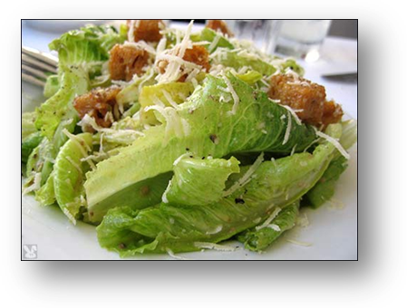
Caesar Dressing:

Ingredients:

- 1/2 c. grated Parmesan cheese
- 1/3 c. olive oil
- 1/3 c. vegetable oil
- 1/3 c. lemon juice
- 1 tsp. Worcestershire sauce
- 1 egg
- Anchovies or anchovy paste to taste
- Salt and pepper
- 2 lg. cloves garlic
- 1 sm. Onion

Method:

Combine all ingredients from Parmesan cheese to onion in blender or food processor. Blend until smooth and season with salt and pepper to taste.

Chicken Caesar

Ingredients:
- Chicken Breast 6 oz.
- Classic Ceasar Double portion
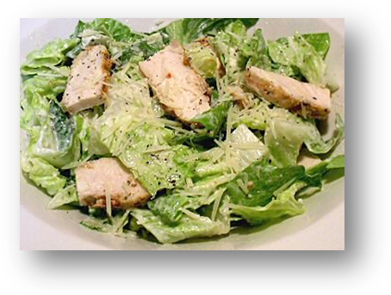
Method:
- Cut broiled chicken breast into slice. Place on top of Caesar

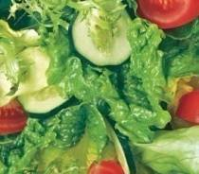
Chicken Bok Choy

Ingredients:
- Bok Choy leaves, sliced into strips
- Romaine leaves, sliced into strips
- Chicken Breast Broiled, sliced
- Ramen Crunchies ¼ cup per salad
- Almonds 1 oz. per salad
- Sesame-Soy vinaigrette 2 oz per salad
- Green Onions, chopped garnish

Method:
- Pour soy dressing over greens and toss.
- Place sliced chicken breast over greens
- Top with ramen crunchies and green onions.

Ramen Crunchies:

Ingredients:

1/2 c. butter
2 tbsp. white sugar
1 bottle of sesame seeds (1 oz.)
2 pkgs. Ramen noodles (broken up), do not use flavor packet
1 sm. pkg. slivered almonds
Method:

In large skillet melt butter over medium heat. Add sesame seed, noodles, almonds and sugar. Stir all the time until lightly browned. Set aside to cool to room temperature.

Dressing:

Ingredients:
3/4 c. vegetable oil
1/4 c. red wine vinegar
1/2 c. white sugar
2 tbsp. soy sauce

Method:

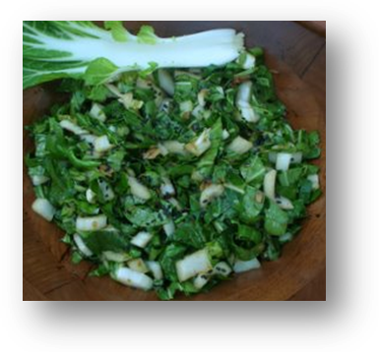
Mix well and chill until ready to use.

Raspberry Chicken

Ingredients:

- Tossed Salad double portion
- Chicken Breast, Broiled and sliced 6 oz.
- Raspberry Dressing 3 oz.
- Fresh Raspberries Garnish

Method:

Assemble chicken breast on top of a double portion tossed salad.

Top with raspberry dressing and fresh raspberries.

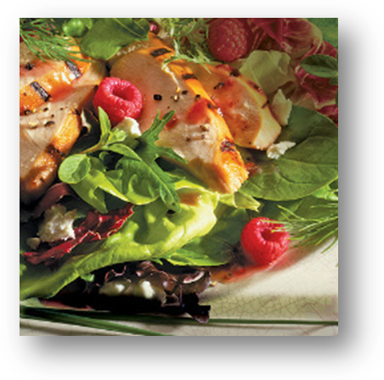

Dressings (all homemade):

Ranch
Mix according to package directions

Thousand Island Dressing

Ingredients:
- 1 gallon salad dressing
- ½ - #10 can chili sauce
- 6 hard cooked eggs, diced
- 2 T. Worcestershire
- 1 large onion diced
- 1 cup sweet pickle relish
- 2 oz. lemon juice
- ½ cup sugar

Method:
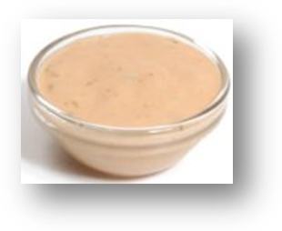
- Mix all ingredients together

Italian
Mix according to package directions. Retail product.

Blue Cheese

Ingredients:
- 1 gallon mayo
- 2 – 5# tubs sour cream
- 3 # blue cheese crumbles
- 2 T. garlic salt
- ¼ cup lemon juice
- 2 T. Worcestershire sauce
Method:
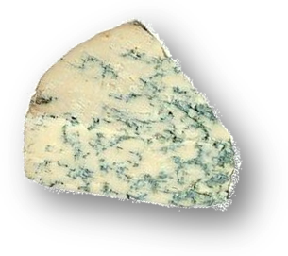
- Mix all ingredients together. Mixture should be thick.

Raspberry Vinaigrette

Ingredients:
- 1/2 c. raspberry vinegar
- 1/4 tsp. salt
- 1/4 tsp. freshly ground black pepper
- 4 tsp. sugar
- 2 garlic cloves, finely chopped (2 tsp.)
- 2 tsp. Worcestershire sauce
- 1 tbsp. Dijon style mustard

Method:

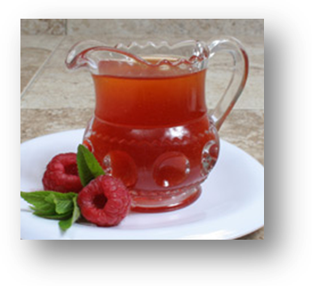
Combine all ingredients and mix well. Refrigerate in a container with a tight-fitting lid. It will keep for months.

Red Western

Ingredients:
- 1/3 cup red wine vinegar
- 2/3 cup catsup
- 2/3 cup sugar
- 1 cup oil
- 1 T. Worcestershire
- 1 tsp garlic salt
- ½ tsp coarse ground pepper

Method:
- Mix all ingredients together. Keep chilled to prevent separation

.

Dinners:

Fresh Bread Retail Product

Broiled Salmon Steak

Ingredients:
- Salmon 8 oz. fillet
- Honey mustard salad dressing
- Bread crumbs

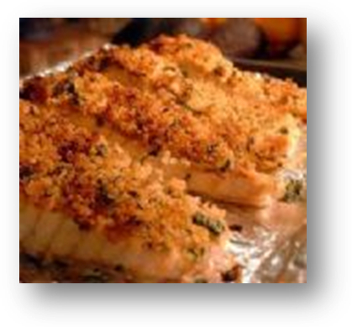
Method:
- Brush salmon fillet with honey mustard salad dressing. Roll in bread crumbs.
- Sauté in clarified butter to brown. Bake in oven to finish. Serve Medium to Medium well.

Chicken Alfredo

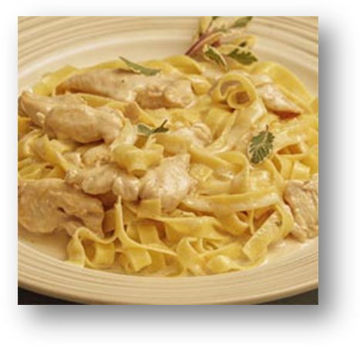Ingredients:
- 1 skinless chicken breast, cut in slices about 1/4 " thick then in bite-size morsels
- 1 clove of garlic, finely diced.
- 1/2 cup broccoli florets, steamed (optional)
- 4 oz pasta (fettuccine, penne, etc.)
- 2 tablespoons unsalted butter, at room temperature (or olive oil for sautéing the chicken and for the sauce)
- 1/2 cup freshly grated Parmigiano Reggiano (Parmesan), at room temperature, plus extra cheese to pass at the table.
- 3/4 cup heavy cream
- salt and freshly ground pepper
Method:
- Cook the pasta in boiling salted water until al dente (to the bite), rinse with hot water, drain and hold for later.
- In the large sauté pan large enough to hold all the ingredients, sauté the chicken in 2 tablespoons of butter or good olive oil until lightly browned. Add garlic and sauté until the aroma of the garlic is evident (without burning the garlic).
- In the sauté pan: ADD the heavy cream. Keep cooking on low-medium heat, stirring occasionally until the mixture reduces slightly and thickens.
- Add the Parmesan cheese to the same pan along with the cooked and well-drained pasta to the sauce. If including broccoli to this dish, add the steamed al dente florets. Mix well with a wooden spoon and simmer to the right consistency. Add salt and pepper to taste.
- Add more heavy cream (or milk) if dish becomes too dry.
Vegetarian Primavera
Substitute fresh veggies (Broccoli, Carrots, Onion, Green Pepper, Red Peppers) for Chicken.

Chicken Cordon Bleu
Ingredients:
- Boneless chicken breast 6 oz.
- Shaved ham 3 oz.
- Swiss cheese 3 oz.
- Standard Breading Procedure

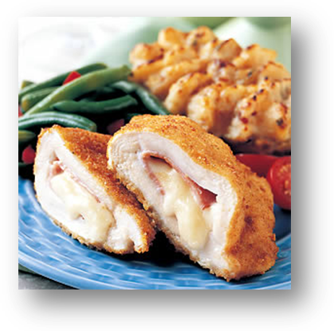
Method:
- Cut a pocket into the chicken breast being careful not to cut all the way thru the breast.
- Stuff ham and Swiss cheese in the pocket.
- Pass thru a standard breading procedure (seasoned flour, egg wash, bread crumbs)
- Sauté in clarified butter to brown. Bake in oven to finish

Chicken Parmesan
Ingredients:
- Chicken breasts, pounded even
- flour, egg wash, and bread crumbs
- Italian tomato sauce
- Mozzarella cheese
Method:
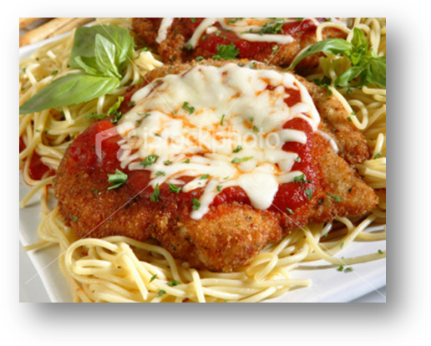
- Pass the pounded chicken breasts thru a standard breading procedure- lightly season and then dredge the seasoned breasts in flour, dip in the egg mixture (beaten egg and milk), then roll in bread crumbs.
- Sauté the breasts in olive oil or mixture of clarified butter and olive oil until golden brown on each side.
- Remove the breasts to a platter and place atop fresh, hot pasta. Top with warm tomato sauce and top with mozzarella cheese.
- Place under broiler just long enough to melt the cheese and serve.

Chopped Sirloin
Ingredients:
- Hamburger 8 oz.
- Sautéed onions 3 oz.
- Sautéed mushrooms 3 oz.
- Brown Gravy 2 oz.
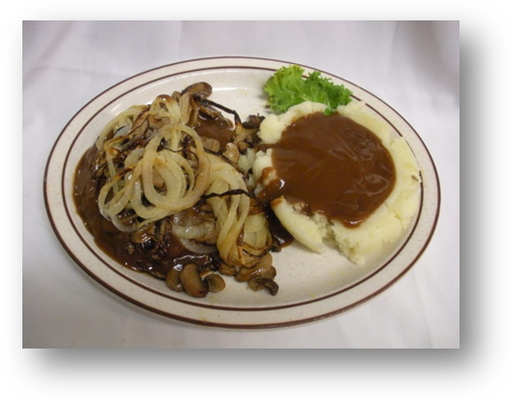
Method:
- Broil burger to desired doneness
- Top with gravy, onions and mushrooms

Dinner Quesadilla
Ingredients:
- Tortilla 1 large
- Green and Red Pepper 5 slices each
- Onion Slices ¼ cup
- Oil/butter to grill
- Chopped chicken 1/2 c.
- Shredded Cheddar Cheese 1/2 c.
- Shredded Lettuce as garnish
- Diced Tomatoes as garnish
- Sour Cream 2 oz.
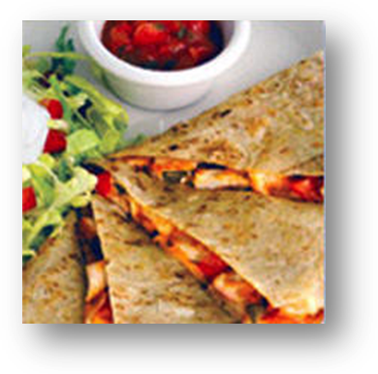
- Guacamole 2 oz.
- Salsa 2oz.
Method:
- Butter one side of each tortilla and put on grill. When grill is hot, lay one tortilla on grill, buttered side down. Spread filling across ½ the tortilla.
- Cook until tortillas have browned and cheese has melted. Fold tortilla in half and remove from grill.
- Cut into 4 wedges. Serve with lettuce and tomato garnish, sour cream, guacamole and salsa.

Steak Sandwich

Ingredients:
- Sirloin steak 6 oz.
- Texas Toast 1 slice
- Garlic Butter to toast bread
- Onions Rings 3 for garnish
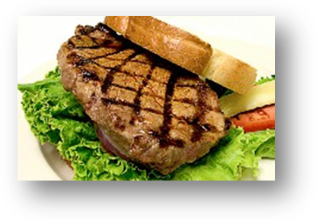
Method:
- Butter bread and grill till browned
- Season steak with ½ garlic salt, ½ seasoned salt
- Broil sirloin to desired doneness
- Serve steak on toast.

Thai Chicken w/Sweet Chili Sauce

Ingredients:
- Chicken Breast, Broiled 6 oz.
- Steamed Rice 1 cup
- Thai Sweet Chili Pepper Sauce 4 oz.
(Mae Ploy)
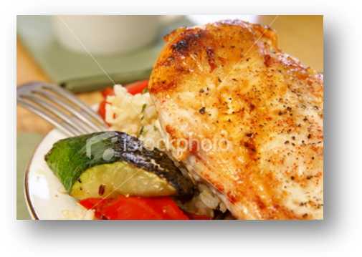
Method:
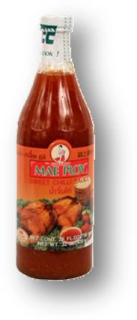
- Broil seasoned chicken breast until done
- Place over rice
- Top with sweet chili sauce

Sunday Brunch

Waffles

Syrup, Strawberries, Whipped Cream

Omelets with green pepper, mushrooms, cheese, tomatoes, onions, bacon bits

Mashed, Gravy, Vegetable

Fresh fruit

Chicken

Baked fish

Chocolate Danish, Cinnamon Rolls, Sticky Caramel Rolls

Desserts: Apple Crisp, Lemon Bavarian Torte, Sacher Torte, Chocolate Chip Cookies, Chocolate Fudge Cake,

Shark Pizzas
10” pie cooked fresh to order
Cheese 8 oz.
Sausage 4 oz.
Pepperoni 2 oz.
Hamburger 4 oz.
Supreme (1/2 above)

Desserts
Ice Cream Sundae
Sorbet*
(*ask your server what this week’s flavor is)
Chocolate Fudge Cake
Double Caramel Pie

Children’s Menu
Includes Fries & Slaw . .

Hamburger
Cheeseburger
Grilled Cheese
Chicken Strips

Potatoes +
Baked,

Hash Browns

French Fries

Steamed Rice

Weekly Specials

Monday—Lunch
Monte Cristo

Tuesday—Lunch
Taco Bar

Wednesday—Lunch
Italian Lasagna

Thursday—Lunch
BBQ Shredded Pork

Friday—Lunch/Dinner
Fish and Chips

Saturday—Dinner
Changes weekly!

Sunday—Sunday Brunch
Changes weekly!

THAI CHICKEN WRAPS
3 chicken breasts
1 tablespoon soy sauce
1 tablespoon vegetable oil
4 twelve inch tortilla wraps
Salad:
1/2 seedless english cucumber, peeled, halved lengthwise and thinly sliced on an angle
2 cups fresh bean sprouts
1 cup shredded or thinly chopped carrots
3 scallions, sliced on an angle
12 leaves basil
1 tablespoon sesame seeds
2 teaspoon sugar
2 tablespoon rice win vinegar
a dash of salt, to taste
Peanut Sauce:
1/4 cup chunky peanut butter
2 tbsp soy sauce
1 tbsp rice wine vinegar
1/4 tsp cayenne pepper
2 tbsp vegetable oil
Cook chicken breasts in a pan with soy sauce and vegetable oil. Combine all salad ingredients together and season with salt.
Whisk sauce ingredients together, pouring in a stream of vegetable oil.
Heat tortillas (on medium saucepan or in microwave).
Pile sliced chicken and salad into wraps and drizzle liberally with peanut sauce before rolling. Slice in half on an angle and serve.

